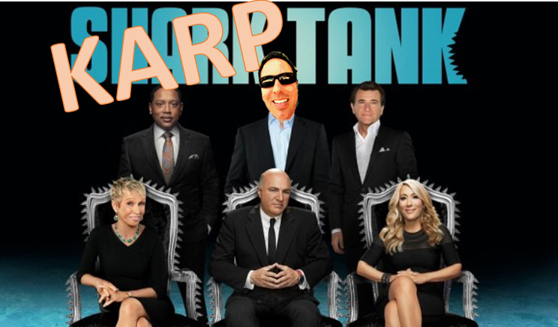
KARPTANK TELEVISION SERIES:
Welcome to The KarpTank Television Show! This show features a live panel of investors who will decide whether to invest money in your StartUp. As a StartUp you will create a business presentation about your company, and future product, based upon pre-assigned topics in the syllabus. Please download the file from Canvas: StartUp Company Profile PPT and complete it/post it in your area right away. Also, create a physical model of any products you pitch to us to hold or see if your product is tangible. If you require a website, then create it to demonstrate your product or service. Be sure to remember that the Karps/sharks want to know all about your StartUp, why you are here today, and they want to see something unique.
The sharks often find weaknesses and faults in a concept, product, or ethical business model, so be prepared with facts, articles, and detailed information. Some of the investors try to soften the impact of rejection, while others will find holes in your product/topic. The sharks and community are ready to see an exciting action-packed meeting between the Startup and the community.
Thank you from the President, CEO, & Producers of KarpTank TV
(download our app from the Google Play store, but not iTunes since android is so much better than apple)
Jason Karp
President WKRP Studios
Charlotte, NC Location

Startup Company –
Items to Address during your actual KarpTank discussion:
- Company Introduction (prepared ahead of time, first week of the course)
- Your Startup Company Employees / Titles / Pictures with Names (see ppt. template)
- Explain and define the technology you will launch. Example: What are driverless cars?
- Sale Pitch Product Video
- Background of the company and products
- Why is this company needed?
- What ethical scenarios does this product address?
- Benefits and Drawback that may exist
- Incorporate Data collected from student Canvas responses (pending publication of your article)
- Incorporate Facts and Research about the technology field and future trends
- Entertain us as if you really need the funding and believe in your company and product.


TEAM CONTRACT
Please create your own contract (or modify this one) and retain it for your own purposes. I do not need a copy. Every team will come up with a different working agreement. While what works for one team certainly will not work for every team, many agreements will contain rules like the following:
Our attitude and culture
- We treat each other with respect, and we intend to develop relationships to enhance trust and open communication.
- We value constructive feedback. We will avoid being defensive and give feedback in a constructive manner.
- We strive to recognize and celebrate individual and team accomplishments.
- As team members, we will pitch in to help where necessary to help solve problems and catch-up on behind schedule work.

Team meetings
- We will hold a regular weekly meeting on:
- Additional meetings can be scheduled to discuss critical issues or tabled items upon discussion and agreement with the team leader.
- All team members are expected to attend team meetings
- The team leader will publish and distribute an agenda
- Meetings will start promptly on time. All members are expected to be on-time.
- Meeting minutes will be distributed within 24 hours after the meeting.
- We will emphasize full discussion and resolution of issues vs. sticking to a timetable.

Communication and Decision-Making
- One person talks at a time; there are no side discussions
- Each person is given a chance to speak their mind while at the same time respecting the group’s time and the meeting timetables. We will be brief and focus on facts, not opinions.
- We emphasize open and honest communication – there are no hidden agendas.
- We de-personalize discussion of issues – no attacks on people.
- We will listen, be non-judgmental and keep an open mind on issues until it is time to decide.
- We emphasize balanced participation of all team members and we will emphasize collaboration and use consensus for important decisions and issues.
- We will maintain the teamwork plan and the schedule.

By typing my name HERE I hereby agree to the rules: JANE DOE
By typing my name HERE I hereby agree to the rules: JANE DOE
By typing my name HERE I hereby agree to the rules: JANE DOE
By typing my name HERE I hereby agree to the rules: JANE DOE

